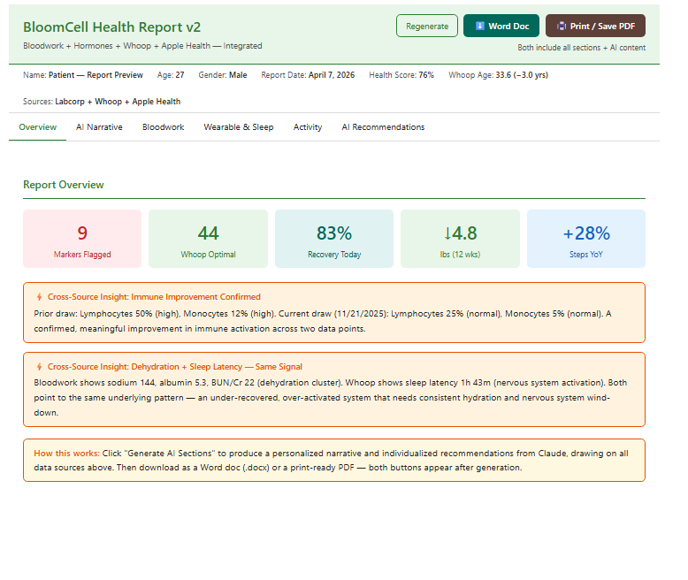Understanding Your Results (AI-Generated)
AI-generated — Written individually for this patient, synthesizing bloodwork, hormone panel, Whoop data, and Apple Health activity trends.
Your results tell a clear story — one of meaningful progress alongside a few patterns worth addressing.
The most significant finding in this draw is the resolution of your immune activation. Your lymphocyte percentage has come down from 50% to 25%, and your monocytes have dropped from 12% to 5%, both now sitting at or within normal range — this is a genuine and measurable improvement, and it suggests your immune system is no longer in an elevated response state. Woven into this positive shift, though, is a cluster of findings that point toward physiological stress from training load and insufficient recovery hydration. Your liver enzymes — AST at 78 and ALT at 42, both above the reference range — reflect the combined demands of muscle breakdown and hepatic stress that are common in high-output athletes, but at these levels they warrant attention. Your dehydration pattern is consistent and multisourced: sodium at 144, albumin at 5.3, and a BUN-to-creatinine ratio of 22 all point toward a chronic, low-grade fluid deficit rather than an acute event, meaning this has likely been building over time. Your anion gap of 22 and elevated homocysteine of 8.3 both suggest B-vitamin insufficiency — particularly thiamine and the methyl-B complex — which adds a metabolic layer to the picture. Your wearable data adds one more piece: last night's sleep latency of 1 hour and 43 minutes is notably elevated against a healthy target of under 20 minutes, and while your overall sleep score was good, the difficulty initiating sleep is a signal that your nervous system may be carrying more activation than the recovery metrics alone would suggest.
Your hormonal foundation is strong. Total testosterone at 735 ng/dL sits in solid mid-range, and free testosterone at 25.1 pg/mL is at the ceiling of the reference range — an excellent profile for a competitive athlete. Thyroid function is fully normal across every marker, ferritin is robust at 202, and vitamin D at 68.8 reflects consistent sufficiency. Your behavioral trend data reinforces this: body weight has come down 4.8 pounds over the past few months, daily steps are up 28% year over year, and your Whoop recovery today is sitting at 83% on what is appropriately a low-strain day. Your pace-of-aging score on Whoop registers you at 3 years younger than your chronological age — a meaningful longevity signal.
Taken together, this is the picture of an athlete whose foundational health is solid and whose immune system is moving in the right direction, but who is carrying a pattern of training-driven physiological load — concentrated in liver stress, dehydration, B-vitamin demand, and nervous system activation at night — that is worth addressing deliberately. The data is not alarming; it is instructive.
Notice: Educational purposes only. Not a medical diagnosis. Review with a qualified healthcare provider.

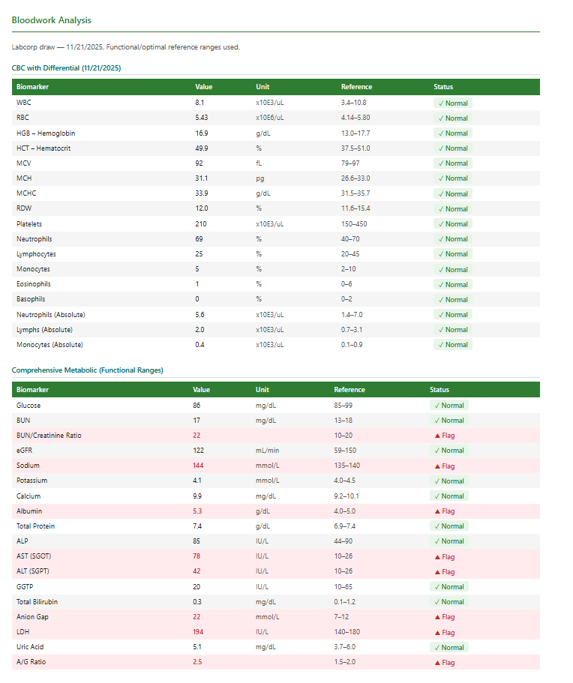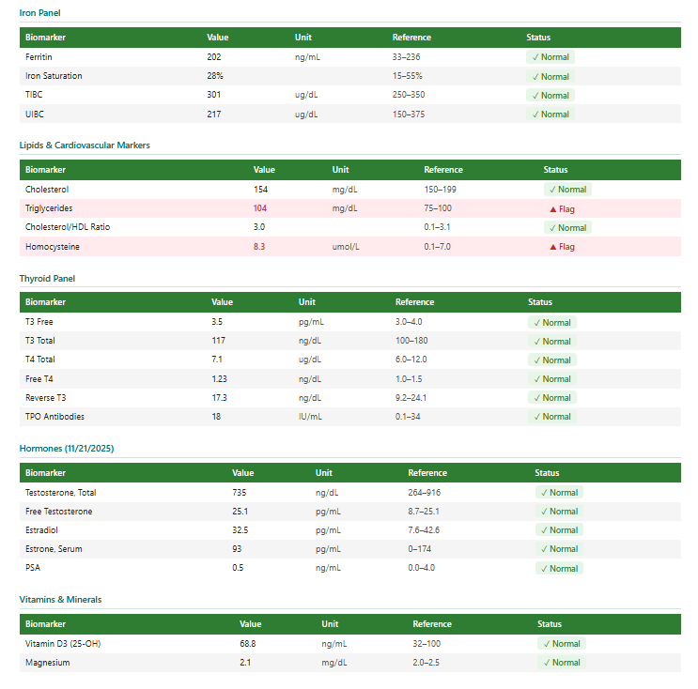
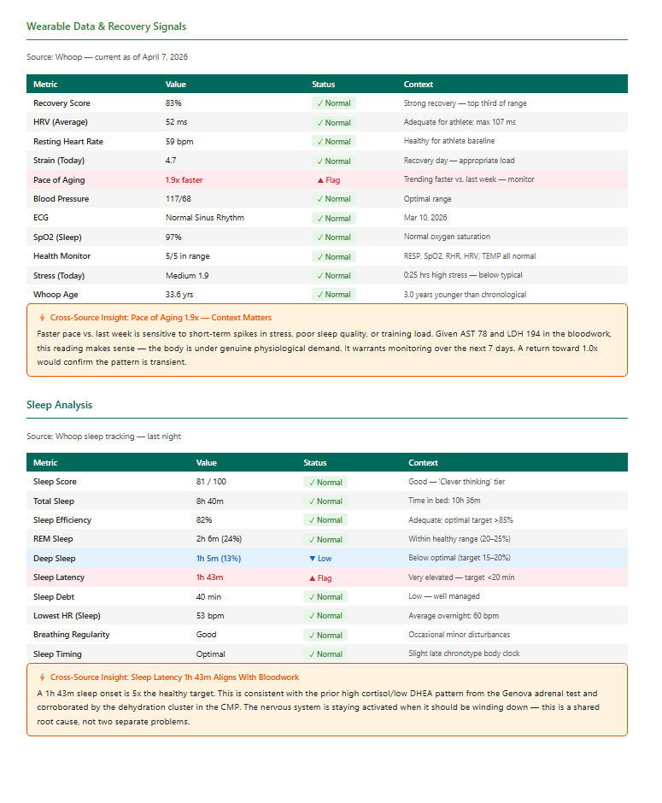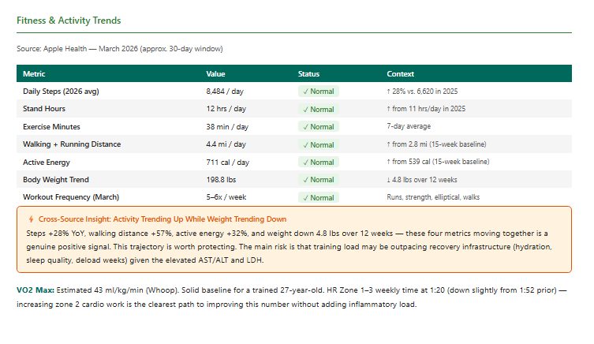

Key Recommendations (AI-Generated)
AI-generated — Individualized to this patient's specific bloodwork values, hormone panel, wearable signals, and activity trends.
Priority Actions — Next 30 Days
This section identifies the five most clinically urgent patterns from your November 21, 2025 bloodwork, wearable data, and health history, ranked by immediate impact on performance, recovery, and long-term risk. Review each priority with your clinician before initiating protocol changes, and use the specific values cited to track progress at your next draw.
1
Hydration — Resolve the Multi-Marker Dehydration Cluster
Four simultaneous markers — BUN/Creatinine Ratio 22 (ref 10–20), Sodium 144 mmol/L (ref 135–140), Albumin 5.3 g/dL (ref 4–5), and A/G Ratio 2.5 (ref 1.5–2.0) — form a convergent hemoconcentration pattern that is elevating secondary markers and masking true metabolic status.
- Target a minimum of 100–120 oz of water daily with deliberate electrolyte repletion (sodium 1,500–2,300 mg, potassium 3,500–4,700 mg), aiming to pull BUN/Creatinine Ratio below 20 and Sodium below 142 mmol/L at next draw.
- Add an intra-workout hydration protocol for all sessions exceeding 45 minutes — 16–20 oz of an electrolyte solution per hour — given that your 38 min/day average exercise load and 4.4 mi daily distance are consistent with daily sweat-driven losses.
- Track morning urine color daily as a low-cost real-time hydration proxy; target pale yellow (urine specific gravity <1.020) before training begins, and bring a 30-day log to your next clinical review.
2
Liver and Muscle Enzyme Load — Reduce AST/ALT Burden
AST at 78 IU/L (ref 10–26, 3x upper limit) and ALT at 42 IU/L (ref 10–26, 1.6x upper limit) with concurrent LDH at 194 IU/L (ref 140–180) indicate overlapping liver stress and muscle breakdown that warrants both training load adjustment and hepatoprotective support.
- Discuss with your clinician whether to temporarily reduce high-intensity training volume by 20–25% for 3–4 weeks and recheck AST and ALT at the 6-week mark, using your current Whoop strain baseline of 4.7 (recovery day) as a ceiling for daily strain until enzymes trend below 40 IU/L.
- Introduce milk thistle (silymarin 420–600 mg/day) and consider NAC (600 mg twice daily) as clinician-approved hepatoprotective agents with evidence for reducing transaminase elevation in athletes under significant training load.
- Eliminate any supplements with known hepatotoxic potential — including high-dose fat-soluble vitamins, herbal pre-workouts, or concentrated protein powders containing artificial sweeteners — and present a full supplement list to your clinician for review against your AST 78 / ALT 42 baseline.
3
Metabolic Imbalance — Correct the Anion Gap and Thiamine/B-Vitamin Insufficiency
Anion Gap at 22 mmol/L (ref 7–12, nearly 2x the upper limit) alongside Homocysteine at 8.3 µmol/L (ref 0.1–7.0) signals co-existing metabolic dysregulation with likely B-vitamin insufficiency — a combination that carries cardiovascular risk and impairs cellular energy production in a competitive athlete.
- Begin a clinician-supervised B-complex protocol targeting thiamine (B1 100 mg/day), riboflavin (B2 50 mg/day), B6 (25–50 mg/day as P5P form), methylfolate (400–800 mcg/day), and methylcobalamin B12 (1,000 mcg/day) — with the specific goal of reducing Homocysteine below 7.0 µmol/L and Anion Gap below 14 mmol/L at the next draw.
- Rule out non-dietary contributors to elevated Anion Gap with your clinician — including lactic acidosis from training-induced anaerobic load, given your 711 cal average active energy output and 5–6x/week workout frequency — via a lactate or venous blood gas panel if clinically indicated.
- Given your confirmed non-celiac gluten sensitivity and gut barrier inflammation (Cyrex Array 2), prioritize B-vitamin absorption by addressing gut barrier integrity simultaneously — a leaky or inflamed gut reduces B-vitamin uptake, which may be driving both the Homocysteine of 8.3 and the Anion Gap of 22 despite adequate dietary intake.
4
Sleep Architecture — Eliminate 1h 43m Sleep Latency and Optimize Deep Sleep
A sleep latency of 1h 43m (target <20 min) combined with Deep Sleep of only 1h 5m (13% vs. optimal 15–20%) is directly undermining recovery quality despite an overall Sleep Score of 81/100, and correlates with your Whoop Pace of Aging signal flagging at 1.9x faster than last week.
- Implement a rigid 30-minute wind-down protocol starting 60 minutes before your target sleep onset — no screens, no training data review, dim lighting, and a room temperature of 65–68°F — with the measurable goal of reducing latency from 1h 43m to under 20 minutes within 2 weeks, tracked nightly via Whoop.
- Address the occasional breathing disturbances flagged in your sleep data by pursuing a formal sleep study or home oximetry night if disturbances persist beyond 4 weeks — particularly relevant given your Lowest HR of 53 bpm during sleep and average overnight HR of 60 bpm, which may reflect autonomic perturbation from disrupted sleep architecture.
- To increase Deep Sleep from 13% toward the 15–20% optimal range, trial magnesium glycinate (300–400 mg 30 minutes before bed), avoid alcohol and high-glycemic foods within 3 hours of sleep, and schedule your last high-intensity training session at least 4 hours before your target sleep onset time.
5
Metabolic and Inflammatory Risk Monitoring — Manage Triglycerides, ANA, and Aging Pace Signal
Triglycerides at 104 mg/dL (ref 75–100), a positive ANA at 1:80 (dense/fine speckled), prior adrenal dysregulation (high cortisol/low DHEA), and a Whoop biological age of 33.6 with a 1.9x accelerated aging pace last week represent a cluster of subclinical signals that individually appear mild but collectively indicate an inflammatory and metabolic trajectory requiring proactive management.
- Reduce Triglycerides from 104 mg/dL toward the <75 mg/dL optimal zone by limiting refined carbohydrate and fructose intake on non-training days, adding omega-3 fatty acids (2–4 g EPA/DHA daily), and correlating dietary timing with your 198.8 lb body weight trend — a continuation of the -4.8 lb improvement already in progress will likely move this marker without additional intervention.
- Schedule a 6-month ANA follow-up with rheumatology or your functional medicine clinician — the 1:80 dense/fine speckled pattern is borderline but requires longitudinal monitoring, particularly given concurrent gut barrier inflammation and prior immune activation (Lymphocytes previously at 50%, now resolving to 25%).
- Recheck DHEA-S and morning cortisol within 60 days to assess whether the adrenal dysregulation pattern is stabilizing — if DHEA-S remains suppressed below 200 µg/dL, discuss low-dose DHEA supplementation with your clinician as a targeted intervention to support the Whoop biological age and counteract the 1.9x accelerated aging pace signal.
Long-Term Strategy — 3 to 6 Months
Your current data reflects a competitive athlete with strong hormonal output (free testosterone at ceiling: 25.1 pg/mL), resolving immune activation, and measurable cardiovascular and metabolic markers that, if unaddressed, will compound over a 12–24 month horizon. The long-term strategy prioritizes reversing your 1.9x accelerated pace of aging signal, correcting the hepatic and metabolic stress pattern driving AST 78 / ALT 42 / anion gap 22, and hardening your recovery infrastructure before cumulative load creates structural damage.
1
Liver & Metabolic Stress Reversal
AST at 78 IU/L (3x upper limit), ALT at 42 IU/L, LDH at 194 IU/L, and triglycerides at 104 mg/dL collectively indicate a hepatic and metabolic environment under sustained strain that will worsen with continued training load if not directly targeted.
- Retest AST, ALT, LDH, and triglycerides at 8-week intervals; the clinical target is AST below 40 IU/L and ALT below 30 IU/L — a reduction of at least 50% from current values within 90 days through training load periodization and nutritional intervention.
- Introduce TUDCA (250–500 mg/day) and NAC (600 mg twice daily) as hepatoprotective supports; these have clinical backing for enzyme normalization in athletes with elevated transaminases from combined training and metabolic load.
- Eliminate dietary hepatic triggers consistent with your confirmed non-celiac gluten sensitivity and hazelnut/soy agglutinin reactivity, as chronic low-grade gut-liver axis inflammation is a direct upstream driver of LDH and transaminase elevation in your clinical picture.
2
Hydration & Hemoconcentration Protocol
Your pattern of BUN/creatinine ratio at 22 (ref 10–20), sodium at 144 mmol/L (ref 135–140), albumin at 5.3 g/dL (ref 4–5), and A/G ratio at 2.5 (ref 1.5–2.0) constitutes a consistent hemoconcentration signature indicating chronic underhydration relative to your 198.8 lb training body mass and 711 cal/day average active energy output.
- Establish a minimum daily hydration target of 0.6–0.7 oz per pound of body weight — approximately 119–139 oz at 198.8 lbs — with electrolyte co-ingestion (sodium 500–1000 mg, potassium 200–400 mg) on training days to normalize the BUN/creatinine ratio toward the 10–14 range at next draw.
- Retest sodium, albumin, A/G ratio, and BUN/creatinine at the 90-day mark; resolution of hemoconcentration is the primary endpoint, and failure to normalize by that draw warrants a nephrology consult to rule out structural contributors.
- Implement pre- and post-training weight tracking on at least 4 days per week to quantify sweat loss and calibrate session-specific fluid replacement, targeting less than 1% body weight loss per session at current 198.8 lb baseline.
3
B-Vitamin & Homocysteine Optimization
Homocysteine at 8.3 umol/L (ref 0.1–7.0) with a concurrent anion gap of 22 mmol/L signals B-vitamin insufficiency — most likely folate, B6, or B12 — that, at your age of 27 with a positive ANA history, elevates long-term cardiovascular and inflammatory risk if left unaddressed.
- Initiate a methylated B-complex supplement providing methylfolate (400–800 mcg), methylcobalamin (1000 mcg), and P-5-P (active B6, 25–50 mg) daily; the clinical target is homocysteine below 7.0 umol/L and anion gap normalization below 12 mmol/L at the 90-day retest.
- Add thiamine (B1) at 100 mg/day given the isolated anion gap elevation at 22 mmol/L, which in a high-output competitive athlete raises the index of suspicion for functional thiamine depletion as a specific contributor distinct from the folate/B12 axis.
- Retest homocysteine and anion gap at 60 days rather than 90 given the cardiovascular risk relevance of homocysteine at your age, and cross-reference with the ANA 1:80 monitoring timeline to assess whether B-vitamin repletion is modulating the inflammatory autoimmune signal.
4
Sleep Architecture & Pace-of-Aging Stabilization
A sleep latency of 1 hour 43 minutes (target under 20 minutes), deep sleep at only 13% (optimal 15–20%), sleep efficiency at 82% (optimal above 85%), and a Whoop-flagged pace of aging running 1.9x faster than the prior week are converging signals that your recovery infrastructure is under stress even on days with strong surface-level recovery scores like today's 83%.
- Address the 1h 43m sleep latency as the highest-priority sleep intervention: implement a strict stimulus cutoff 90 minutes before target sleep time, remove screens from the sleep environment, and evaluate magnesium glycinate (300–400 mg at bedtime) as a low-risk, evidence-supported intervention for sleep onset — targeting latency below 20 minutes within 30 days.
- Increase deep sleep from 13% toward the 15–20% optimal range by prioritizing consistent sleep timing (your body clock shows a slight late chronotype — maintain a fixed wake time to anchor circadian rhythm), and monitor whether the occasional breathing disturbances noted in your WHOOP data warrant a formal sleep study if deep sleep remains below 14% at the 60-day review.
- Track Whoop biological age and pace-of-aging weekly as a composite long-term outcome metric; the current gap between chronological age 27 and Whoop age 33.6, combined with the 1.9x acceleration signal, should narrow as hydration, hepatic stress, B-vitamin status, and sleep architecture are corrected — with a 12-month target of pace of aging at or below 1.0x.

